Full Class Diagram

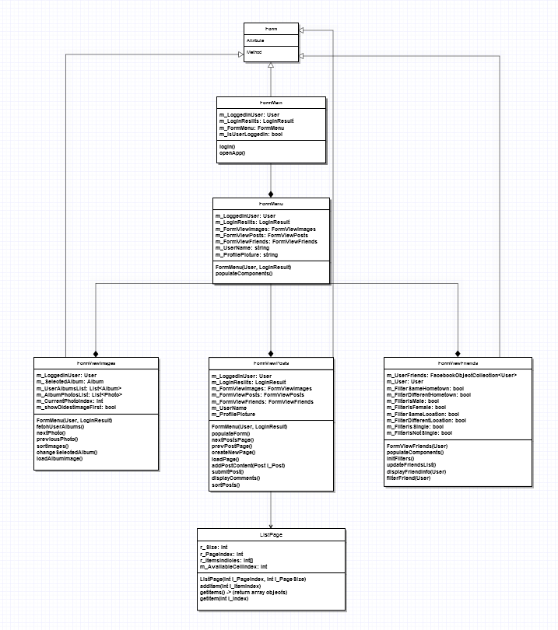

Upper Class Diagram

Downard Class Diagram

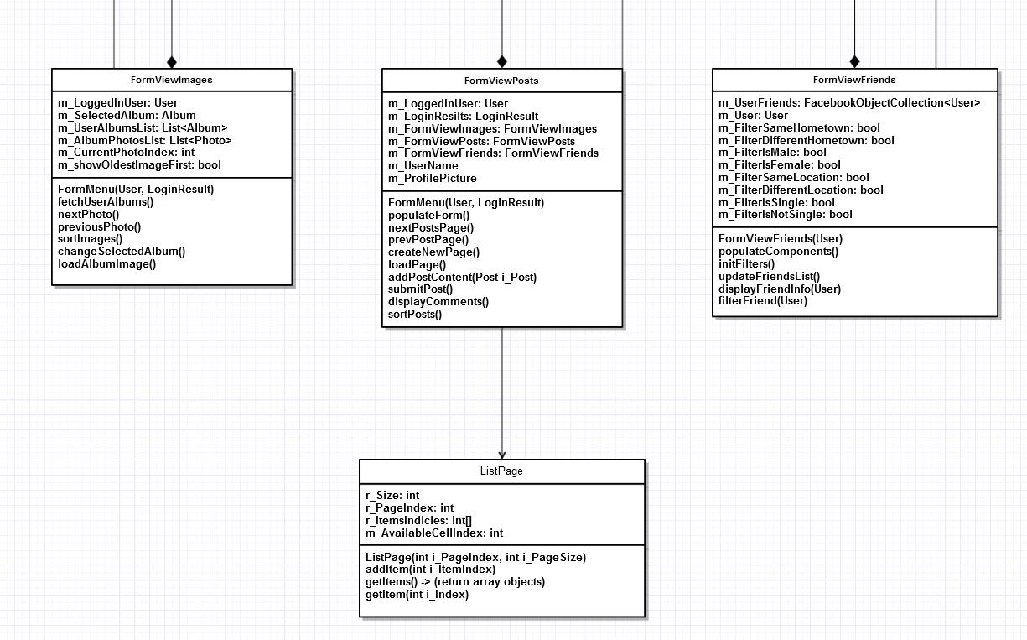

Use Case Diagram

Sequence Diagram

